TFT Model — Progress Report
Temporal Fusion Transformer — Monthly Sales Forecasting
This report documents the iterative development of a Temporal Fusion Transformer (TFT) sales-forecasting model — from initial feature engineering through loss-function comparisons, backtesting, and a known limitation currently being addressed.

Iteration 1 — Predicting for 3 Months
Three configurations were tested for a 3-month forecast horizon (June–August 2026):
Iteration Kind | Month | Predicted Sales
No feature engineering. Original Covariates | Jun-26 | 2,79,581
 | Jul-26 | 55,206
 | Aug-26 | 53,696
No feature engineering. Swapped Covariates with previous year (i.e., 2025) covariates | Jun-26 | 3,93,843
 | Jul-26 | 3,43,243
 | Aug-26 | 3,49,957
Feature engineering applied (see Feature Engineering Strategy below) | Jun-26 | 2,97,713
 | Jul-26 | 2,69,899
 | Aug-26 | 2,76,194

Feature Engineering Strategy
- PITRU_PAKSH and PITRAPAKSHA_DAYS were identical columns — PITRAPAKSHA_DAYS was dropped.
- Removed TOTAL_DAYS_FESTIVE_PHASE_I, TOTAL_DAYS_FESTIVE_PHASE_II, TOTAL_DAYS_FESTIVE_PHASE_III, and TOTAL_DAYS_PITRU_PAKSH — these were either 0 or constant across all months.
- Removed PROP_EVENT_PITRU_PAKSH, PROP_EVENT_FESTIVE_PHASE_I, PROP_EVENT_FESTIVE_PHASE_II, PROP_EVENT_FESTIVE_PHASE_III, and NUM_FESTIVE_DAYS_MONTH.
Collapsed 29 individual festival-day columns into a single TOTAL_FESTIVAL_DAYS feature: Dussehra (Vijayadashami), Akshaya Tritiya, Bhai Dooj, Buddha Purnima, Chhath Puja, Dhanteras, Diwali, Eid-ul-Fitr, Ganesh Chaturthi, Ganga Dussehra, Govardhan Pooja, Guru Purnima, Hanuman Jayanti, Hartalik Teej, Holi, Holika Dahan, Jagannath Rathyatra, Janmashtami, Karwa Chauth, Lohri, Maha Shivaratri, Makar Sankranti/Pongal, Nag Panchami, Navratri, New Year, Onam, Raksha Bandhan, Republic Day, Vasant Panchami, and Vishwakarma Puja.
Created LAST_YEAR_CONTRIBUTION: for a given month, this is that month's contribution to its own fiscal year — e.g., for April 2023 it is (April 2022 sales ÷ FY'23 total sales).

Iteration 2 — 6-Month Horizon, Engineered Features
Loss function: MSE. Learning rate selected via the Darts LR Finder.

Model Configuration
Parameter | Value
input_chunk_length | 12
output_chunk_length | 6
batch_size | 512
dropout | 0.1
likelihood | None
loss_fn | torch.nn.MSELoss()
n_epochs | 100
random_state | 42
gradient_clip_val | 0.1
Callbacks | LossLogger, EarlyStopping
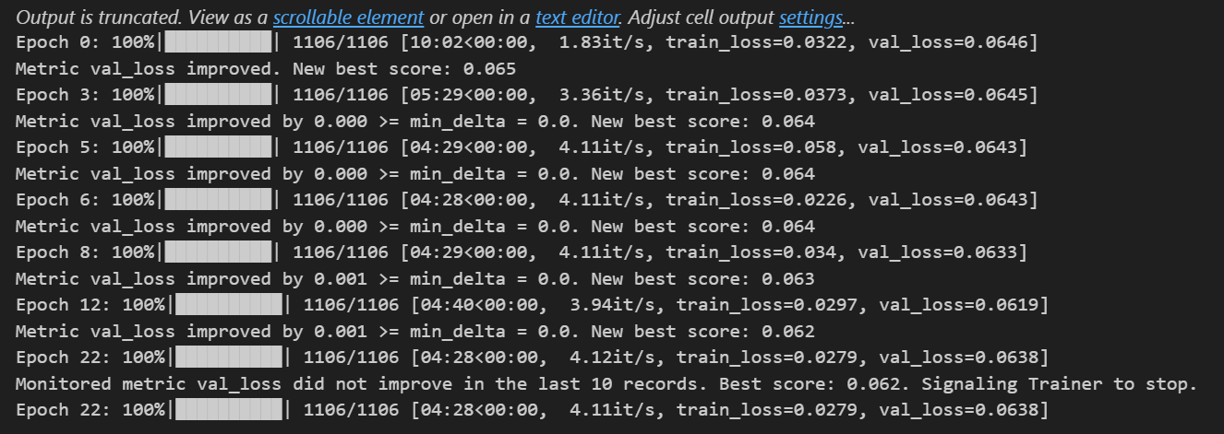
Training log — MSE loss (Iteration 2)
Insight: Validation loss improves only marginally after the first few epochs (0.0646 → 0.062) before early stopping triggers at epoch 22. The model converges very quickly and then plateaus, which can indicate the model is reaching the limit of what these features/configuration can explain rather than continuing to learn.
Output:
Month | Predicted Sales
June | 386790
July | 350689
August | 335238
September | 316078
October | 635328
November | 596278

Iteration 3 — 6-Month Horizon, Modified Configuration
Output: mean prediction from Quantile loss.

Configuration Changes
Setting | Value
Train set | Apr'23 – May'25
Val set | Jun'24 – May'26
Lookback data | Feb'25 – May'26
Lookahead data | Jun'26 – Nov'26
Epochs | 100 → 200
Patience | 10 → 25
input_chunk_length | 12 → 16
Loss function | Quantile loss
Output used | Mean prediction from Quantile loss
Output:
Month | TFT Predicted Monthly Sales
June | 4,16,260
July | 3,35,549
August | 2,94,278
September | 2,64,782
October | 12,34,499
November | 8,52,511
Deviation from the last-4-year average sales and from last year's sales, using the mean prediction from Quantile loss, is shown below.
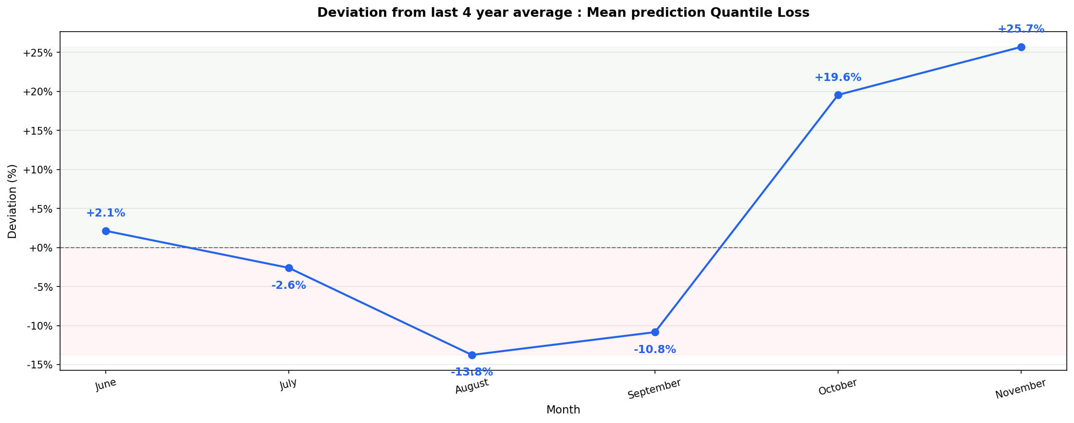
Deviation from last 4-year average sales — Mean prediction, Quantile loss
Insight: The model undershoots the 4-year average through the middle of the horizon — June is close to flat (+2.1%) but July through September drift to as low as -13.8% (August). It then overshoots sharply into October (+19.6%) and November (+25.7%). The forecast is not uniformly biased high or low; it swings by roughly 40 percentage points from August to November alone.
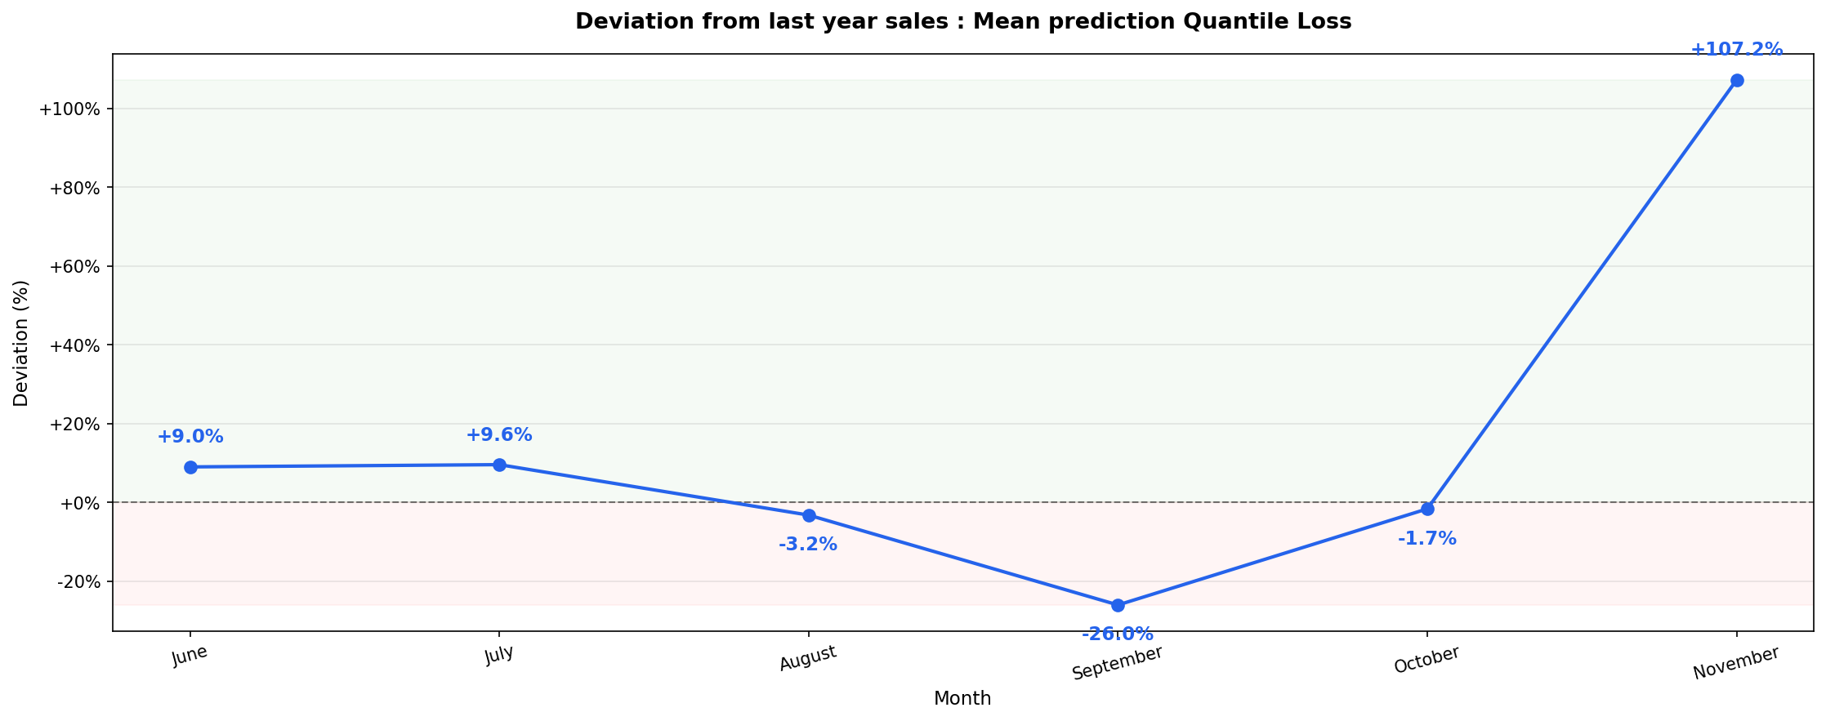
Deviation from last year's sales — Mean prediction, Quantile loss
Insight: Against last year's actuals specifically, September is understated by -26.0% while November is overstated by +107.2% — more than double last year's figure. A same-horizon swing of this size between two adjacent months suggests the festive-period features are not yet being weighted consistently across the back half of the forecast window.

Iteration 4 — 6-Month Horizon, Modified Configuration
Output: percentiles (P10 / P50 / P90) from Quantile loss.

Configuration Changes
Setting | Value
Train set | Apr'23 – May'25
Val set | Jun'24 – May'26
Lookback data | Feb'25 – May'26
Lookahead data | Jun'26 – Nov'26
Epochs | 100 → 200
Patience | 10 → 25
input_chunk_length | 12 → 16
Loss function | Quantile loss
Output used | Percentiles from Quantile loss
Output:
Month | P10 | P50 | P90
June | 1,31,205 | 3,50,816 | 7,87,673
July | 1,02,561 | 2,87,514 | 6,36,908
August | 82,101 | 2,47,342 | 5,71,676
September | 79,907 | 2,15,034 | 5,15,230
October | 5,38,560 | 13,03,353 | 18,32,654
November | 2,09,857 | 7,24,979 | 16,46,160
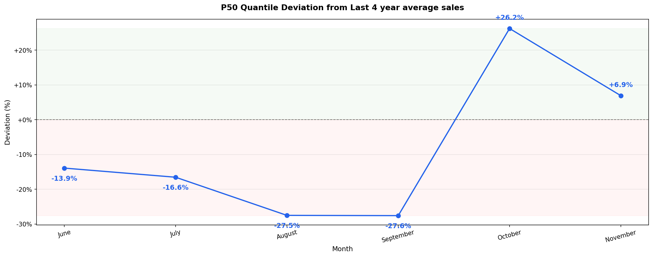
P50 deviation from last 4-year average sales
Insight: The median (P50) forecast undershoots the 4-year average for four of six months — as low as -27.6% in September — before jumping to +26.2% in October. This is the same undershoot-then-overshoot shape seen in Iteration 3's mean prediction, which indicates the pattern is structural to the model/feature setup rather than an artifact of using the mean vs. the median.
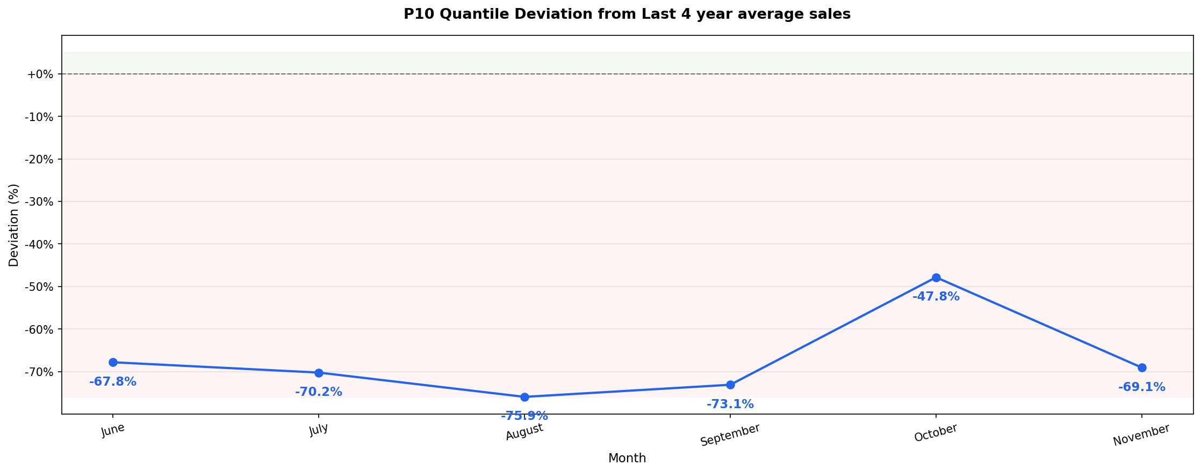
P10 deviation from last 4-year average sales
Insight: The P10 (lower bound) sits 68–76% below the 4-year average in every single month, including October and November where the median itself is running above average. A lower bound this far below history in every month — even the months the median overshoots — points to the quantile spread being too wide to be useful as a planning range without recalibration.
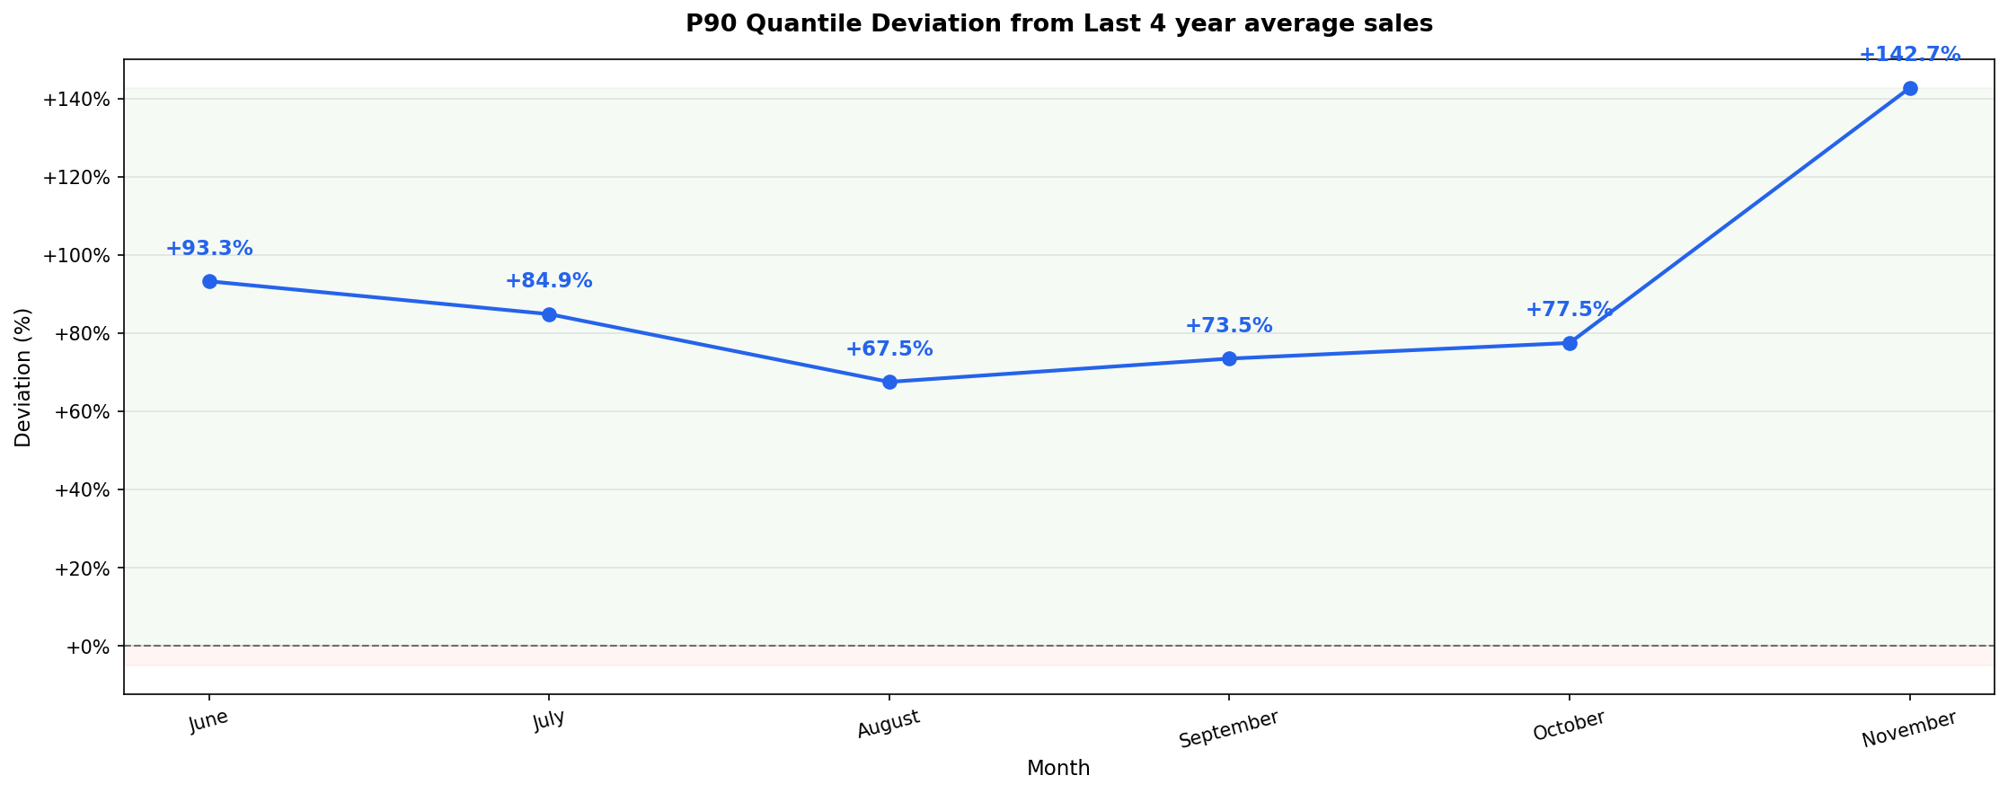
P90 deviation from last 4-year average sales
Insight: The P90 (upper bound) mirrors the P10 pattern: +68% to +143% above the 4-year average in every month, including the months the median undershoots. Taken together, the P10–P90 band spans roughly -76% to +143% even in a comparatively unremarkable month like August — too wide to support confident month-level decisions in its current form.
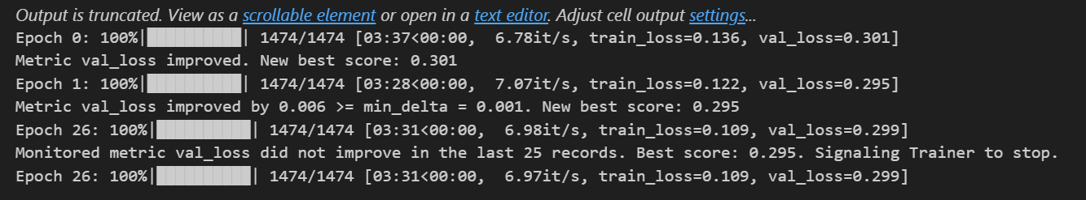
Train and validation loss — Quantile loss
Insight: Validation loss improves only from 0.301 to 0.295 (≈2%) between epoch 1 and the epoch-26 stopping point — a very small improvement for 26 epochs of training, and consistent with the early-plateau pattern also seen in Iteration 2's MSE run.

Model Configuration
Parameter | Value
input_chunk_length | 16
output_chunk_length | 6
batch_size | 128
dropout | 0.1
likelihood | QuantileRegression(quantiles=[0.1, 0.5, 0.9])
loss_fn | None
n_epochs | 100
random_state | 42
gradient_clip_val | 0.1
Callbacks | LossLogger, EarlyStopping
Note: the configuration list above states epochs were increased to 200, but the model code for this run specifies n_epochs=100. Worth confirming which value was actually used before this report is finalized.
Note: the source material references a model architecture diagram for this run ("model architecture using quantile loss") but no diagram image was attached — flagging this as a gap to fill before this report is finalized.

Iteration 5 — 6-Month Horizon, Modified Configuration
Output: percentiles (P10 / P50 / P90) from Quantile loss.

Configuration Changes
Setting | Value
Train set | Apr'23 – May'25
Val set | Jun'24 – May'26
Lookback data | Feb'25 – May'26
Lookahead data | Jun'26 – Nov'26
Epochs | 100 → 200
Patience | 10 → 25
input_chunk_length | 12 → 16
Loss function | Quantile loss
Output used | Percentiles from Quantile loss
Output:
Month | P10 | P50 | P90
June | 1,31,205 | 3,50,816 | 7,87,673
July | 1,02,561 | 2,87,514 | 6,36,908
August | 82,101 | 2,47,342 | 5,71,676
September | 79,907 | 2,15,034 | 5,15,230
October | 5,38,560 | 13,03,353 | 18,32,654
November | 2,09,857 | 7,24,979 | 16,46,160
Note: this configuration and output table are identical to Iteration 4 in the source material. Flagging this rather than silently merging or removing it — worth confirming whether Iteration 5 was meant to capture a different change that didn't make it into the draft.

Iteration 6 — 6-Month Horizon, Modified Configuration
Loss function: Huber loss.

Configuration Changes
Setting | Value
Train set | Apr'23 – May'25
Val set | Jun'24 – May'26
Lookback data | Feb'25 – May'26
Lookahead data | Jun'26 – Nov'26
Epochs | 100 → 200
Patience | 10 → 25
input_chunk_length | 12 → 16
Loss function | Huber loss
Output:
Month | Total Predicted Sales
June | 5,07,213
July | 4,04,020
August | 3,68,492
September | 3,38,404
October | 12,83,292
November | 6,71,600
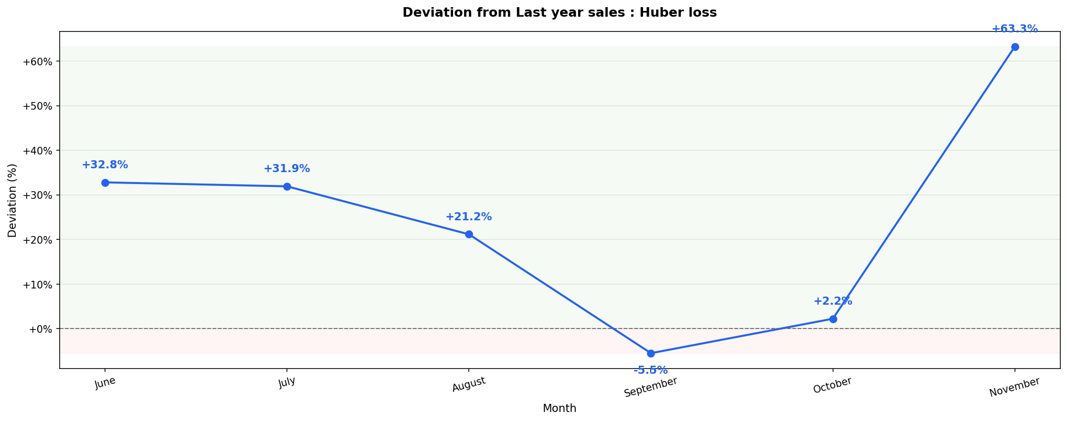
Deviation from last year's sales — Huber loss
Insight: Huber loss overstates last year's sales in five of six months — June through August by 21–33%, and November by 63.3% — with September the lone exception at -5.5%. This is a much more one-sided bias than the quantile-loss runs, which undershot the early months and only overshot toward the end.
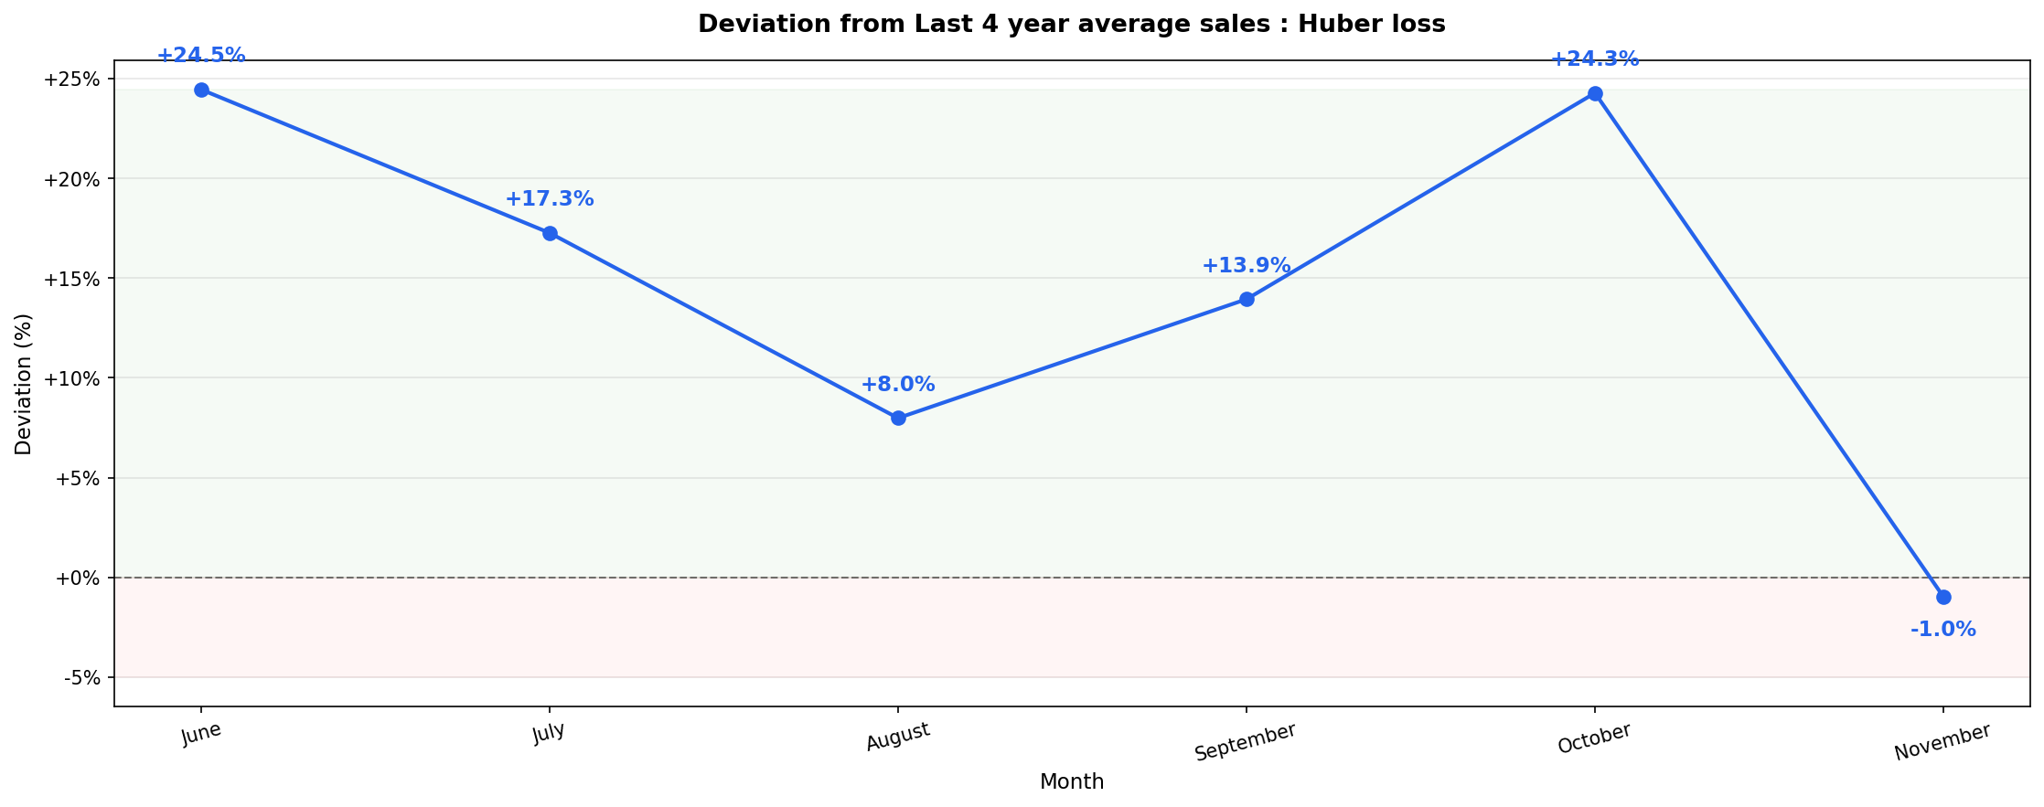
Deviation from last 4-year average sales — Huber loss
Insight: Against the 4-year average, Huber loss overstates every month except November (-1.0%), ranging from +8.0% (August) to +24.5% (June). The direction of the bias is consistent across months, which makes Huber easier to characterize than the quantile runs — but it is still off in every month, and in the opposite direction from quantile loss's early-horizon undershoot.
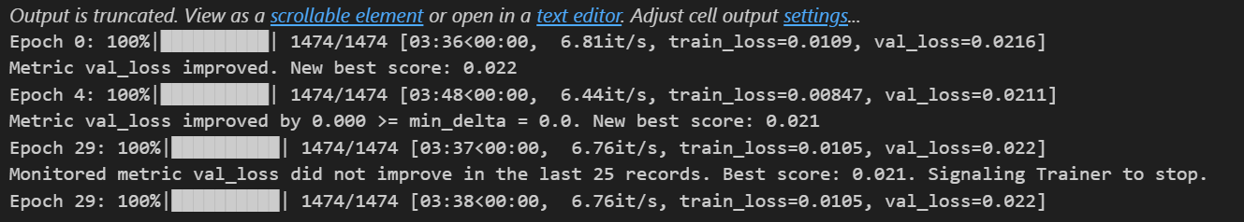
Train and validation loss — Huber loss
Insight: Validation loss improves from 0.0216 to a best of 0.021 before plateauing and stopping at epoch 29 — the smallest relative improvement of the three training runs shown in this report, again consistent with an early plateau rather than continued learning.

Model Configuration
Parameter | Value
input_chunk_length | 16
output_chunk_length | 6
batch_size | 128
dropout | 0.1
likelihood | None
loss_fn | torch.nn.HuberLoss(delta=0.1)
n_epochs | 200
random_state | 42
gradient_clip_val | 0.1
Callbacks | LossLogger, EarlyStopping
Note: as with Iteration 4, the source material references a model architecture diagram ("model architecture of Huber loss") with no diagram image attached.

Details as Requested by Soumakshya

1. Backtest — Quantile Loss vs. Huber Loss (June 2025 – November 2025)
Both the Quantile-loss model and the Huber-loss model were backtested on June 2025 – November 2025, a window with known actuals.
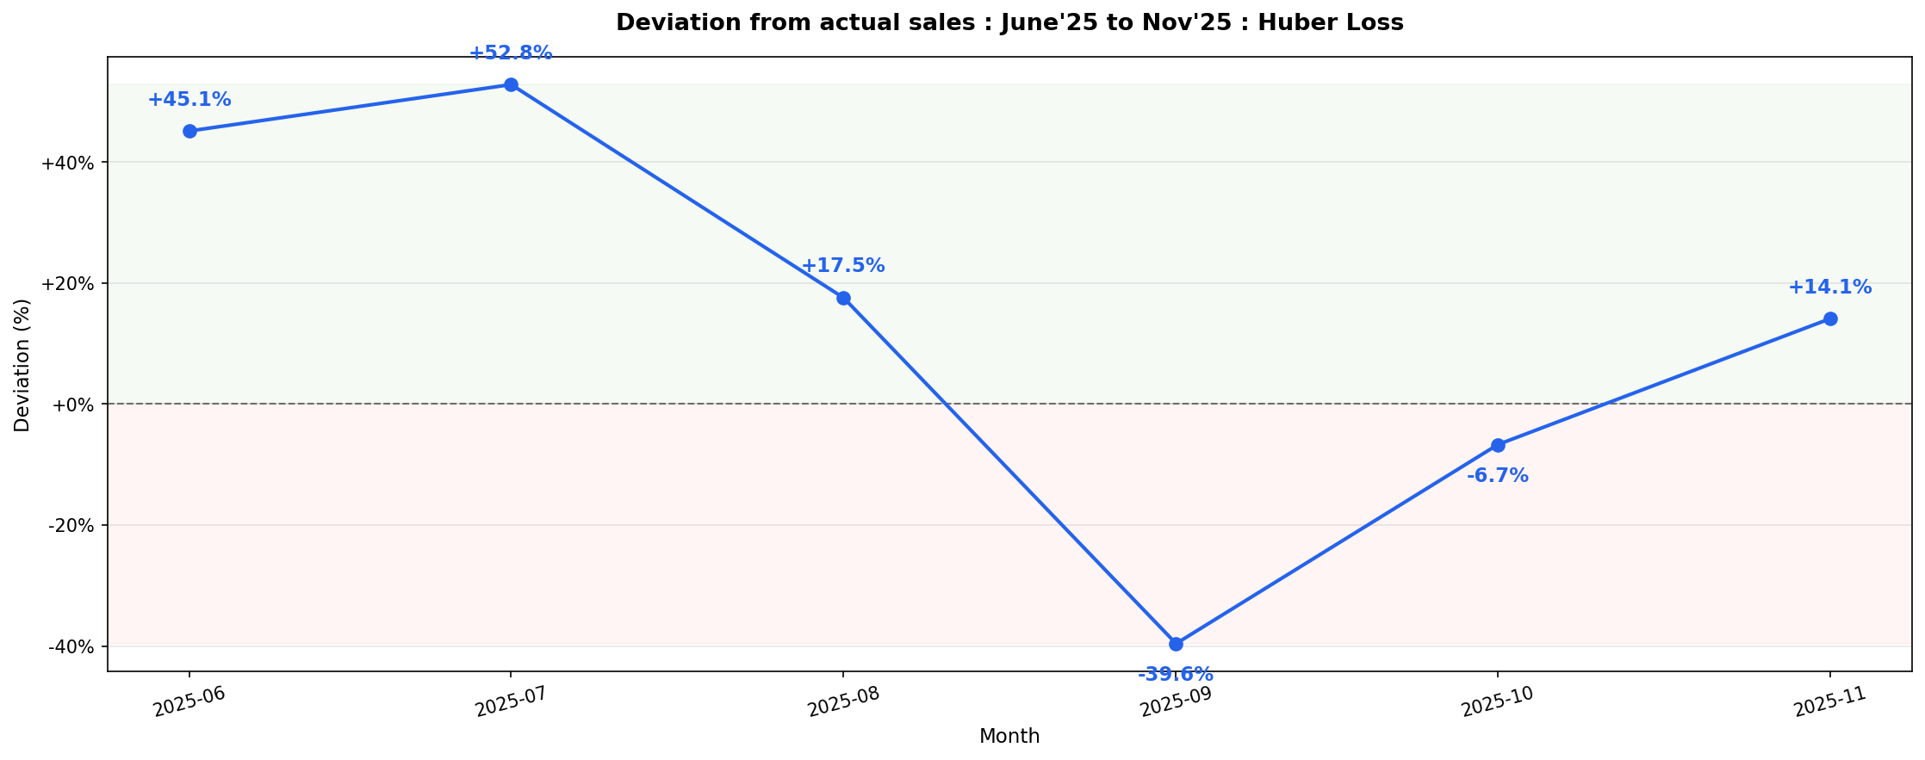
Deviation from actual sales, Jun'25 – Nov'25 — Huber loss
Insight: On a window where actuals are already known, Huber loss over-predicts June–August by 17.5–52.8%, then swings to a -39.6% under-prediction in September before partially recovering. A model that flips from +52.8% to -39.6% within three months, on data it can be checked against, is not yet stable enough to anchor monthly commitments on.
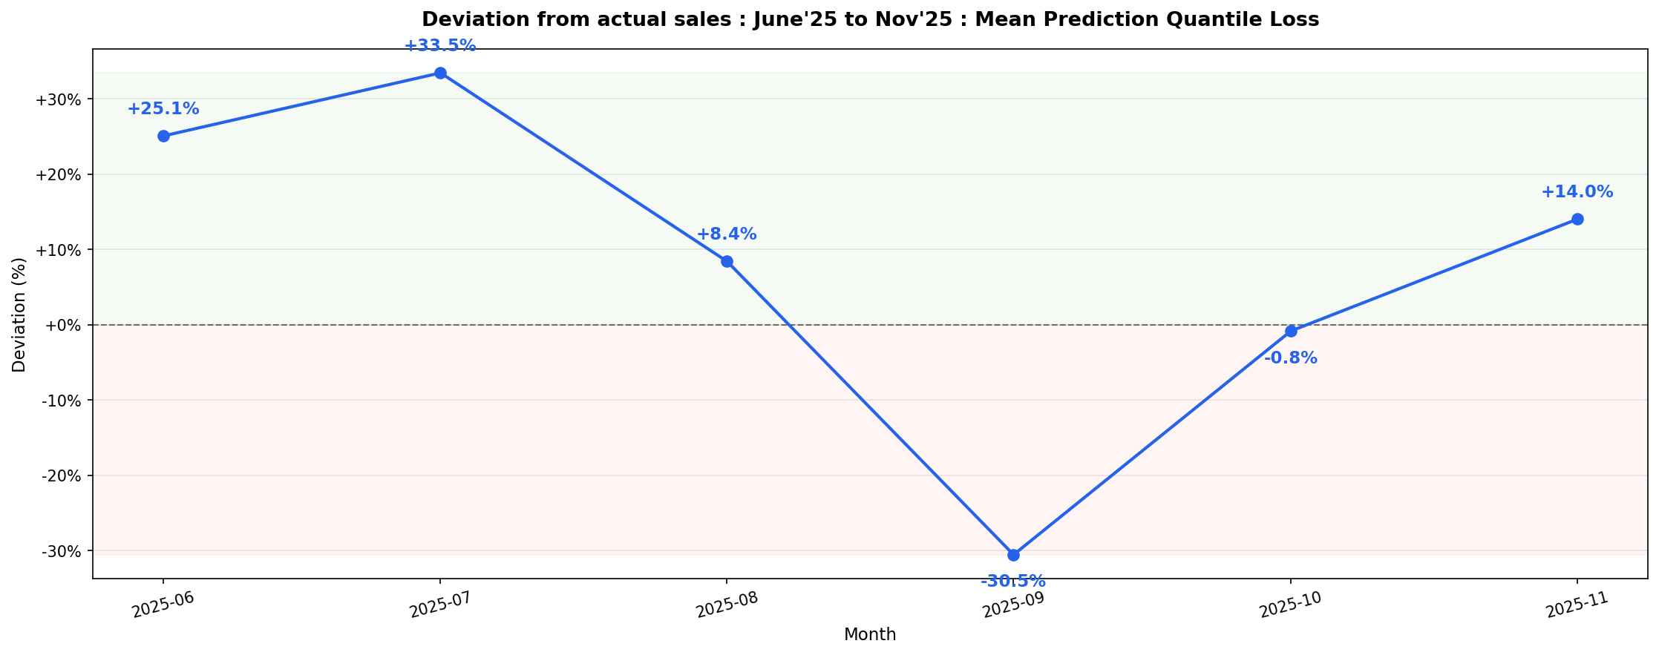
Deviation from actual sales, Jun'25 – Nov'25 — Mean prediction, Quantile loss
Insight: The quantile model's mean prediction follows the same shape on the same backtest window — over-predicting summer, under-predicting September (-30.5%) — but with smaller swings than Huber loss throughout. September is the common weak point for both loss functions on data with known outcomes, which is a stronger signal than the forward-looking forecasts alone.

2. Encoder and Decoder Importance
Note: this section is listed in the source material as a heading only — no encoder/decoder importance plots were attached. This is the same encoder/decoder importance data already discussed separately; happy to generate and insert the corresponding charts here on request.

Known Limitation — Training Window Momentum Issue
Finding: with input_chunk_length = 16, training ended in May'25, so the model never saw the FY'26 decline. This is believed to be the cause of the model's overprediction.
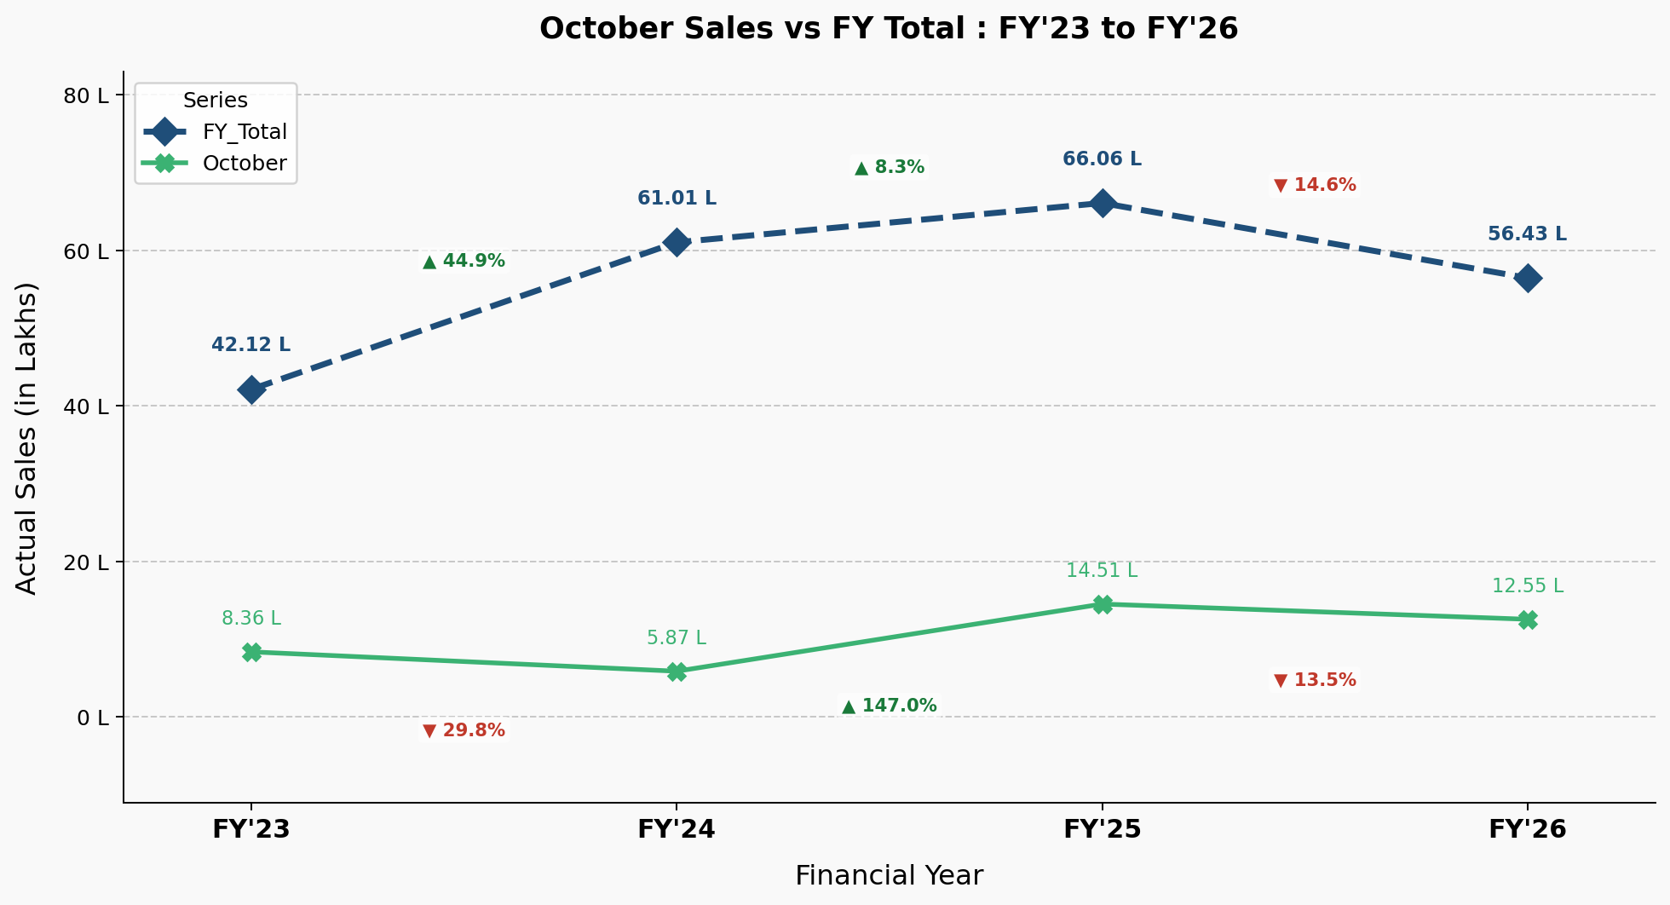
October sales vs. FY total — FY'23 to FY'26
Insight: October swings far more than the FY total: -29.8% (FY24), +147.0% (FY25), then -13.5% (FY26) for the month itself, against a much milder -14.6% to +44.9% range for the FY total. FY'26 total sales are down 14.6% year-on-year — the decline this model's training window (ending May'25) never saw, and the proposed root cause of the overprediction described above.
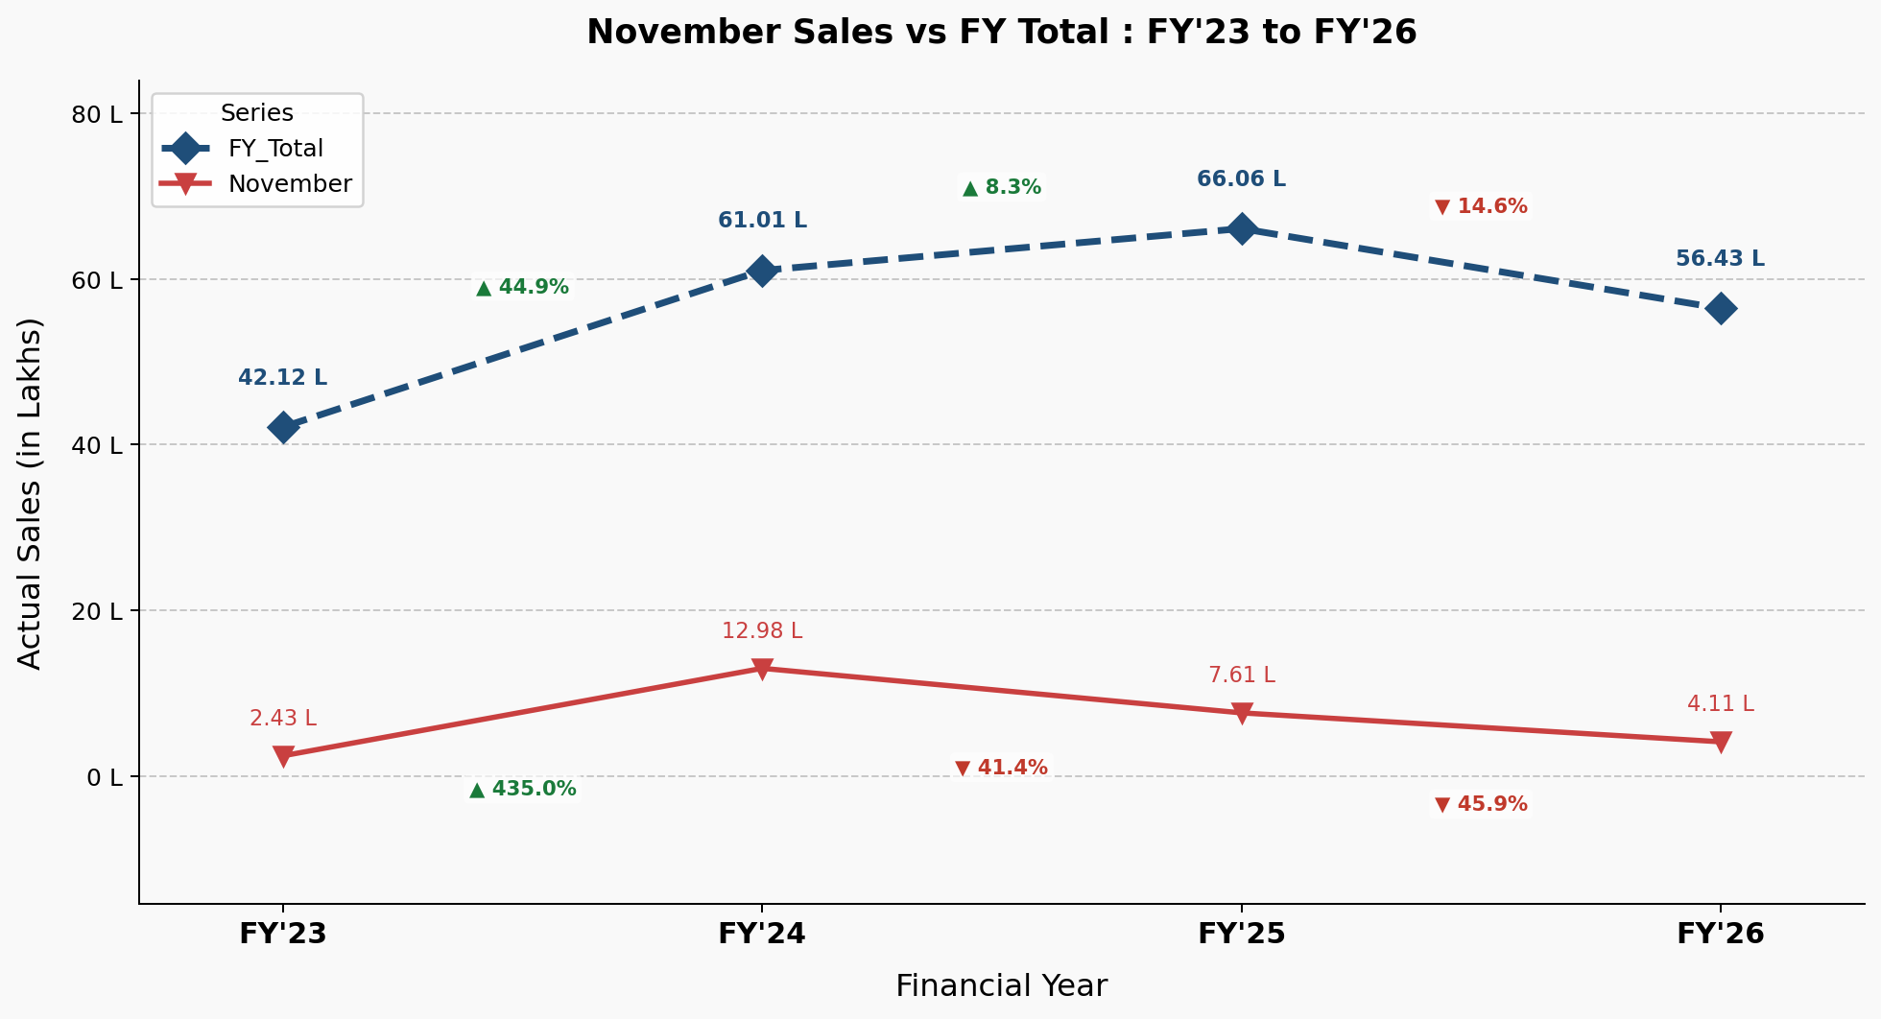
November sales vs. FY total — FY'23 to FY'26
Insight: November is the most volatile single month in the dataset: +435.0% (FY24), then two consecutive declines of -41.4% (FY25) and -45.9% (FY26). A month swinging this hard is the hardest of the six to anchor on with only a 12–16 month lookback window.
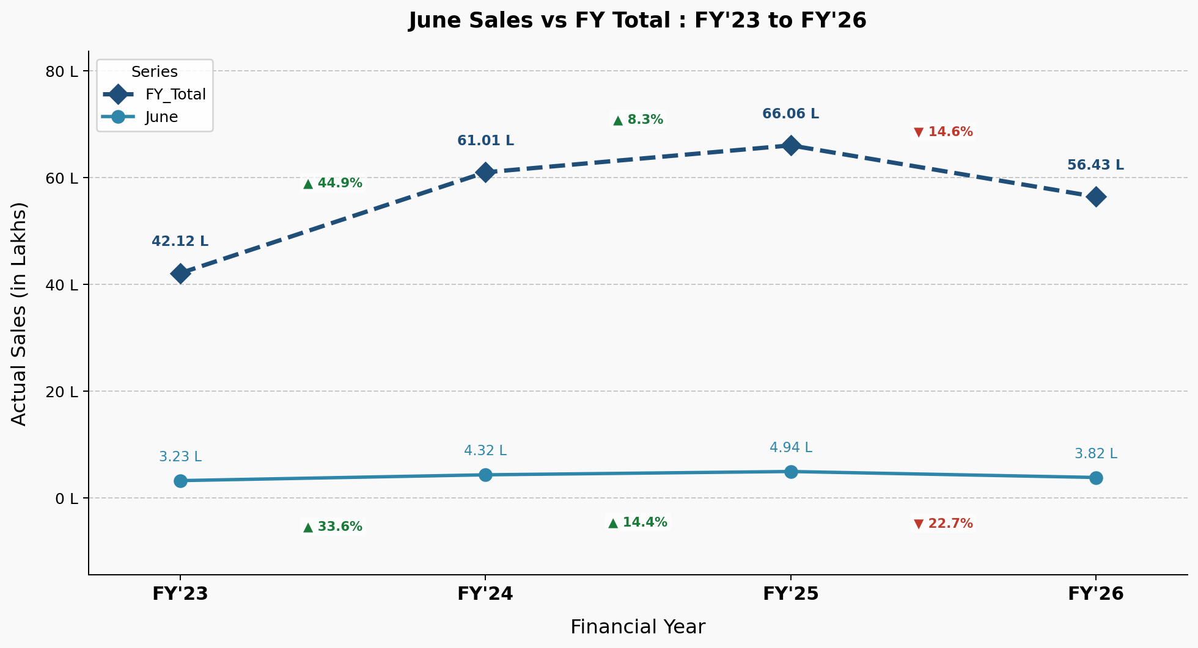
June sales vs. FY total — FY'23 to FY'26
Insight: June is comparatively stable (3.2L–4.9L across four years, ±34% at most) relative to October/November — consistent with June being the most reliably forecast month across every iteration earlier in this report.
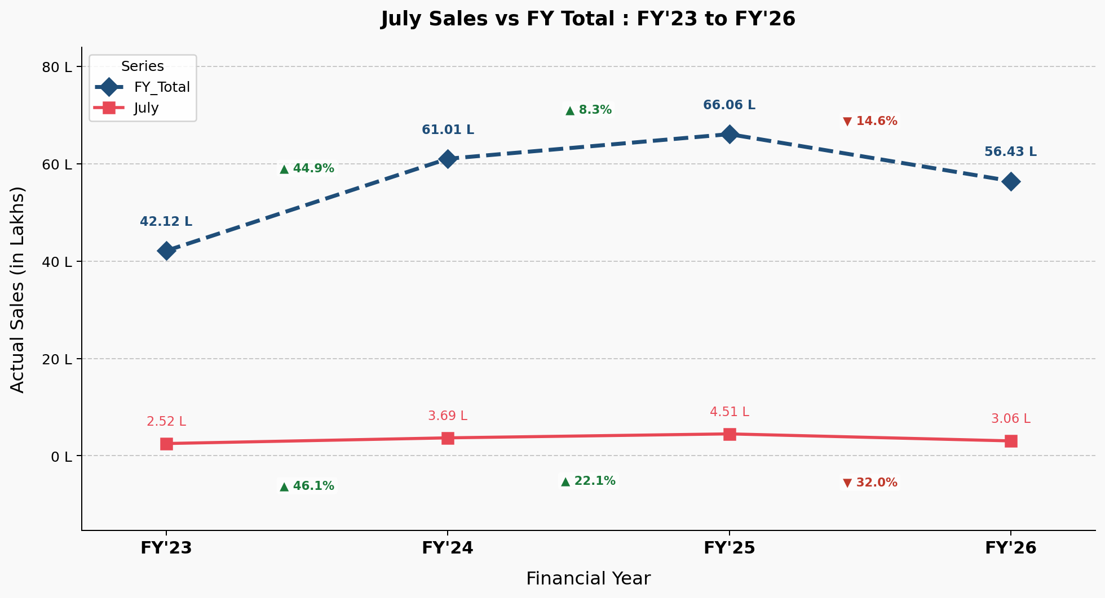
July sales vs. FY total — FY'23 to FY'26
Insight: July shows similar moderate volatility to June (2.5L–4.5L, -32.0% to +46.1%) — no sign of the extreme swings seen in October/November.
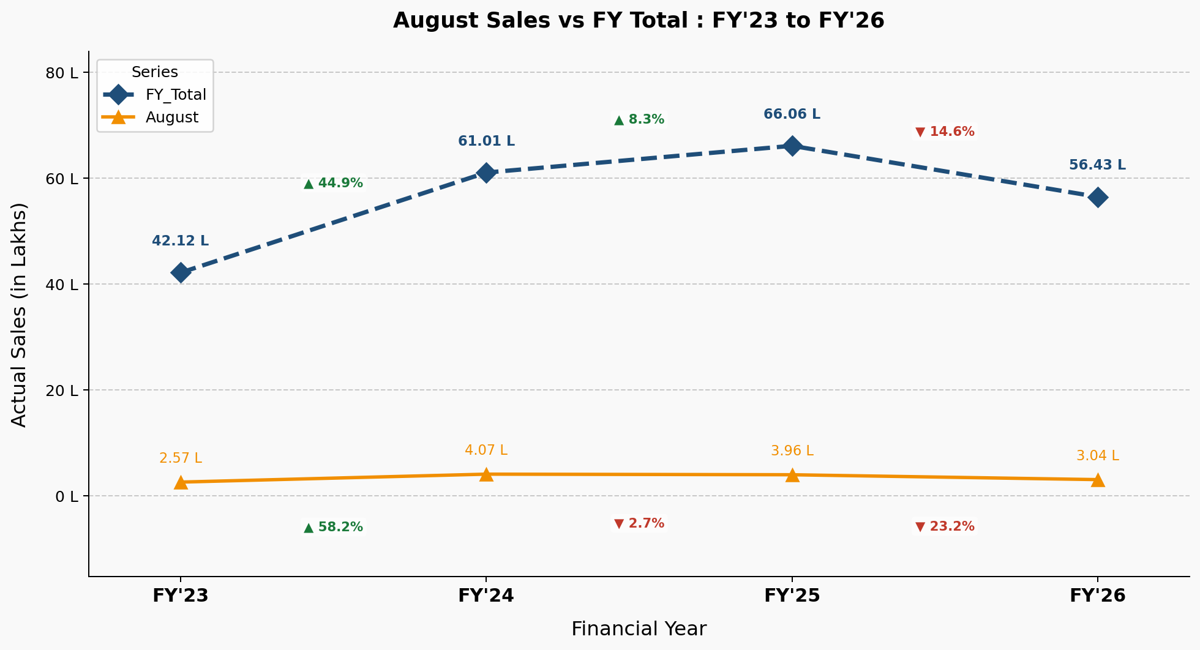
August sales vs. FY total — FY'23 to FY'26
Insight: August stabilized in FY24–25 (-2.7%) before dropping 23.2% in FY26 — a milder version of the same late-year softening visible in October/November, but starting from a smaller base.
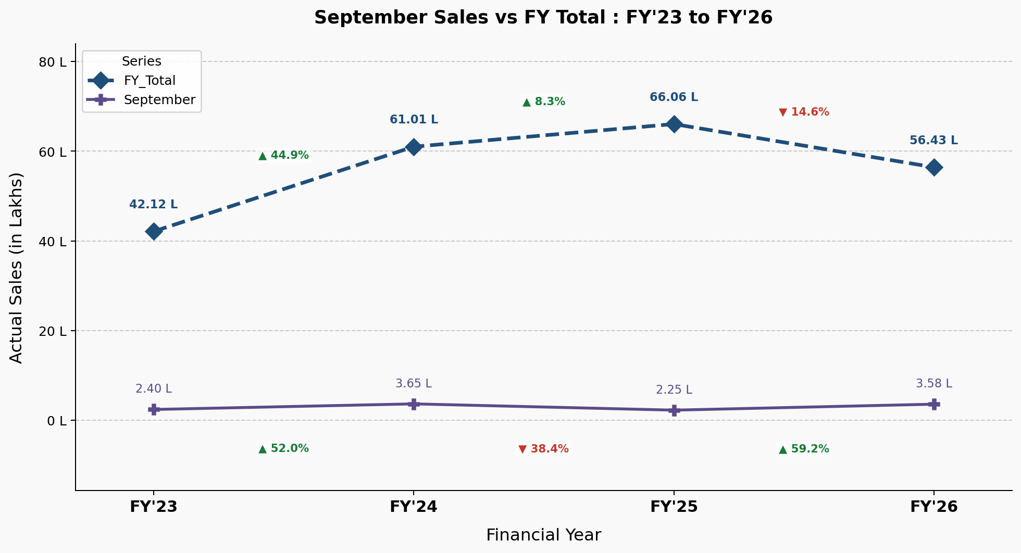
September sales vs. FY total — FY'23 to FY'26
Insight: September is the only one of the six months where FY26 moved up (+59.2%) against a year that was down overall — which may explain why every model run in this report (mean, P50, and Huber) missed September in the same direction.

Recommendation
To address the momentum issue, the following configuration is currently being tried:
Setting | Value
input_chunk_length | 12
output_chunk_length | 6
Training data | Apr'23 – Sep'25
Val data | Oct'24 – May'26
Lookback data | Jun'25 – May'26
Lookahead data | Jun'26 – Nov'26
Loss function | Quantile loss
Epochs | 200
Patience | 25
Batch size | 128

